Overview :-
It helps security professionals identify vulnerabilities, misconfigurations, and security weaknesses in systems, networks, and web applications.
Nessus works by scanning a target system and comparing its configuration against a large database of known vulnerabilities. The tool uses thousands of plugins that detect different security issues such as outdated software, weak encryption protocols, open ports, and web application vulnerabilities.
C
r
e
a
t
e
d

w
i
t
h

M
o
b
i
O
f
f
i
c
e
The results of a Nessus scan are presented in a detailed report that includes the vulnerability name, severity level, plugin ID, description, and recommended solutions. These reports help security teams prioritize vulnerabilities and implement appropriate remediation strategies.
Regular vulnerability scanning is an important part of proactive cybersecurity management because it helps organizations detect and fix weaknesses before attackers can exploit them.

Target Website
Target Web Application: https://public-firing-range.appspot.com/
This platform is intentionally vulnerable and used for cybersecurity learning and vulnerability testing.
Target IP
Target IP Address: 142.250.183.116
Vulnerability Table
S.N Plugin
Vulnerability Severity o ID
1 SQL Injection High 11219
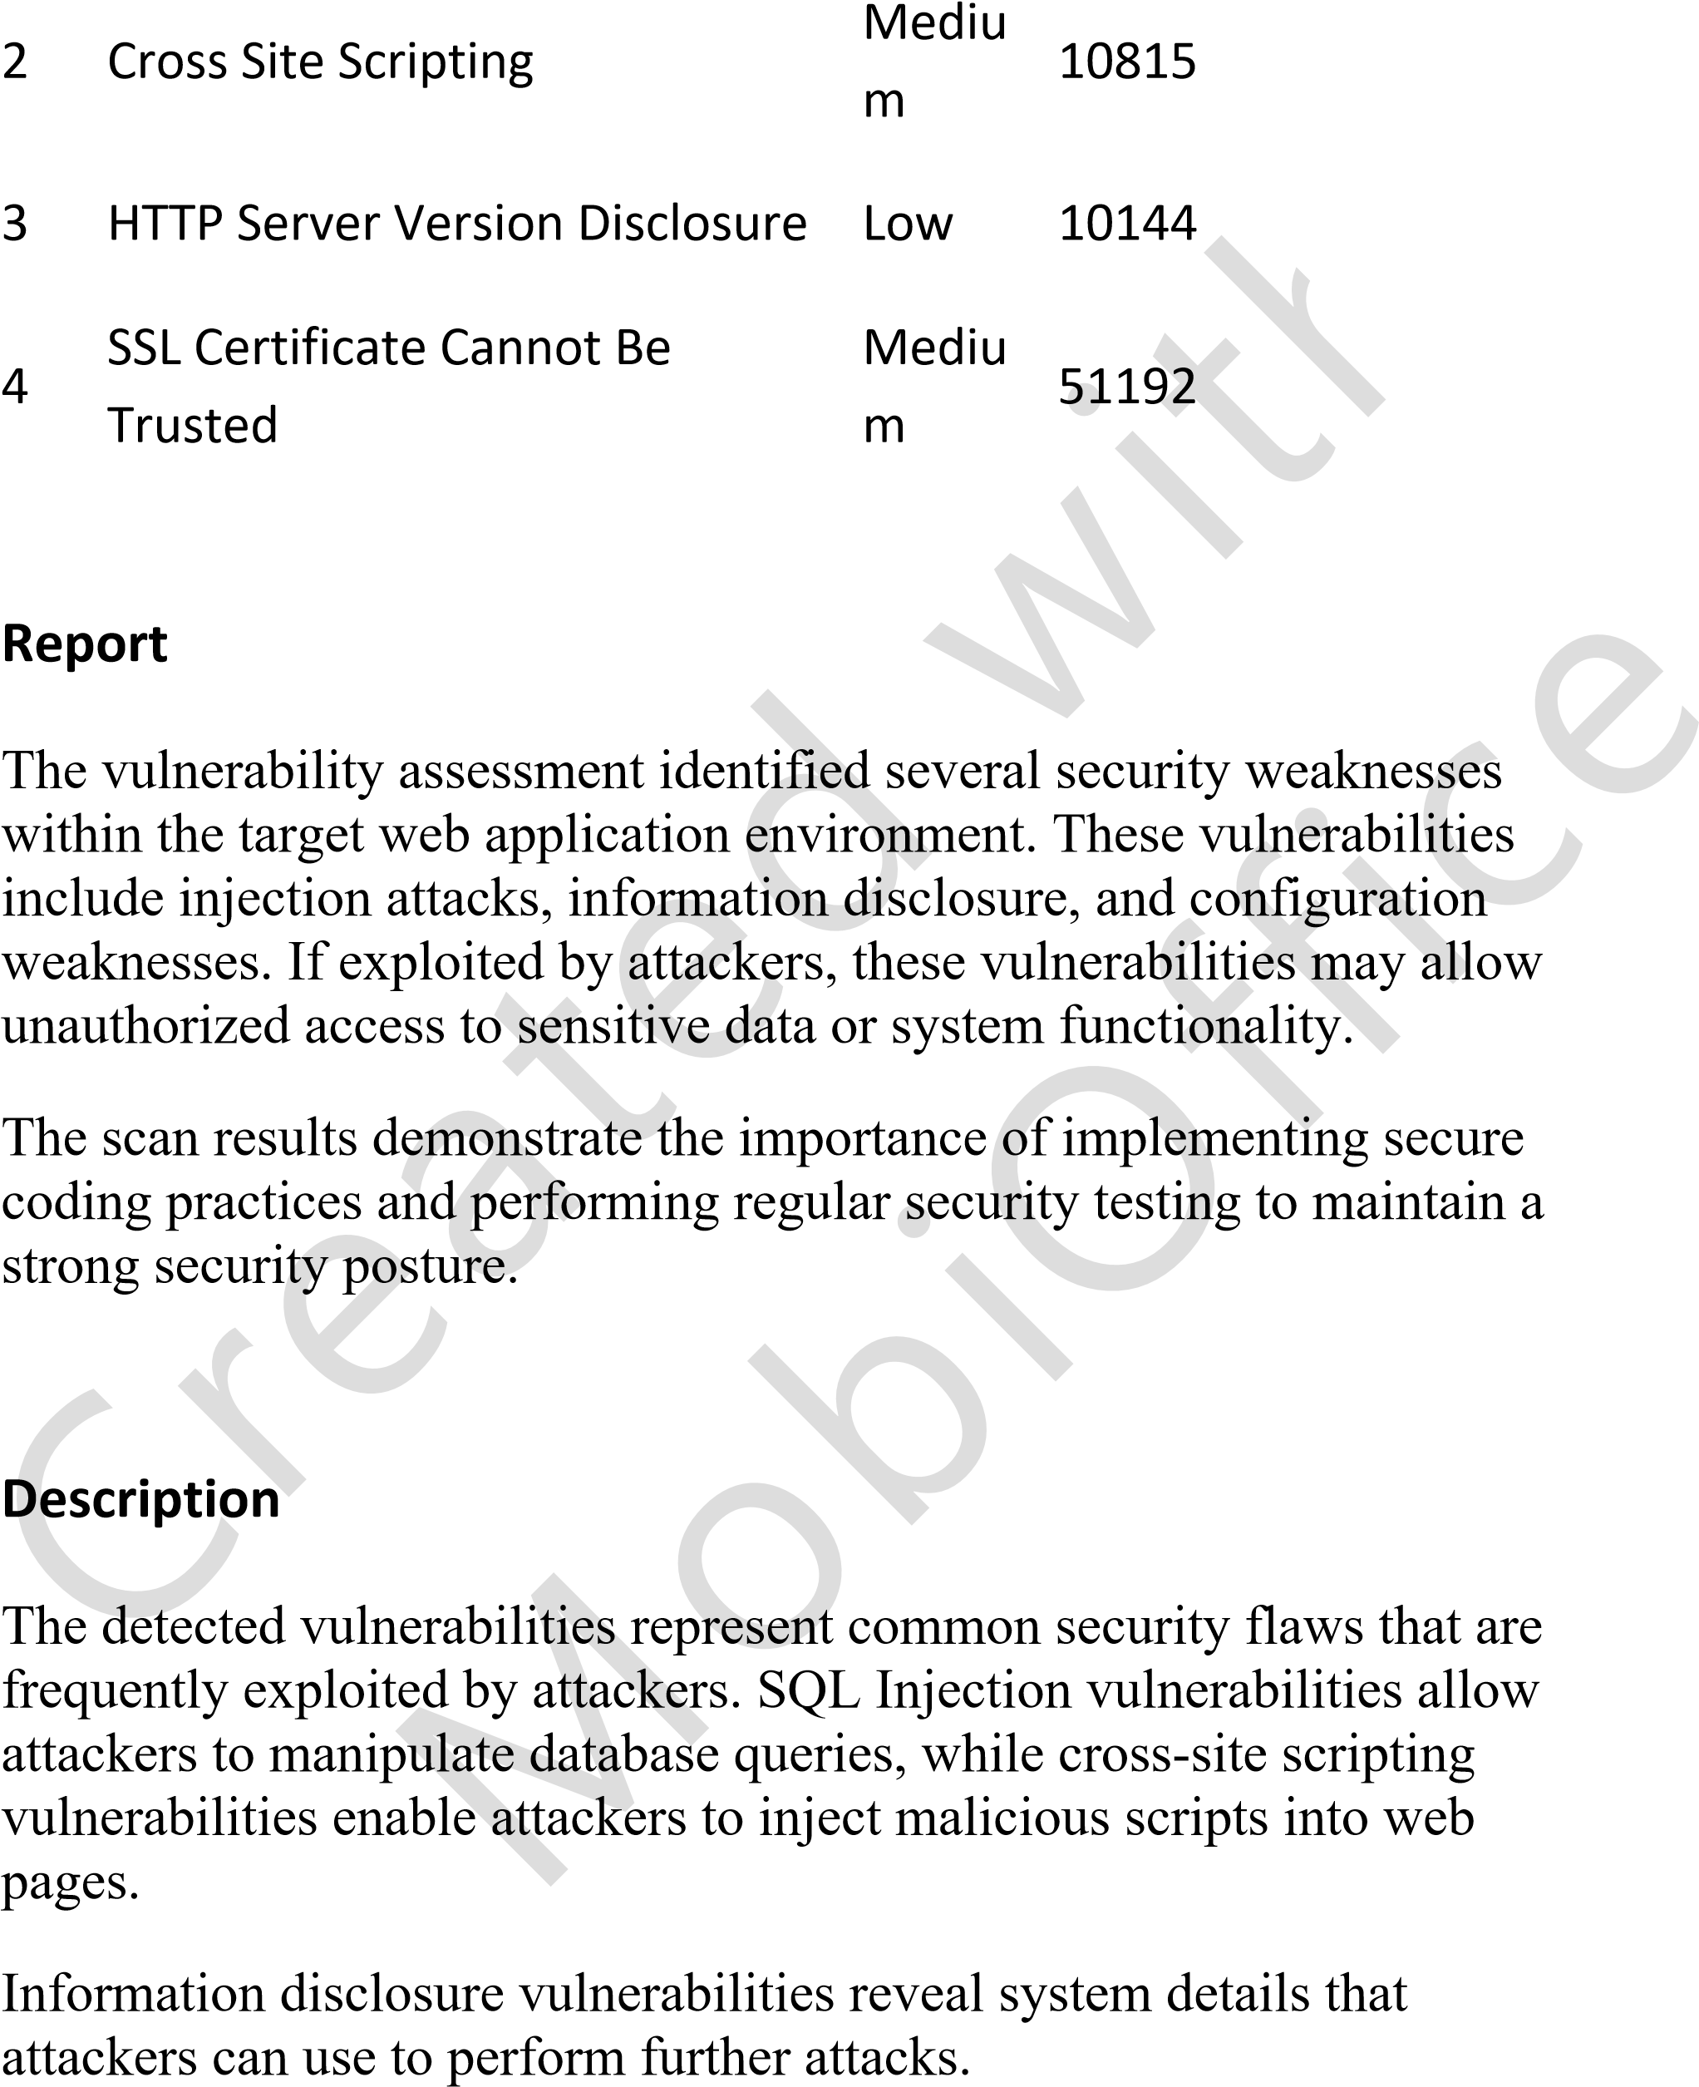

Solution
